EADS NA Defense Test & Services

Software Design Document

1553 Serial Bus
WCEM Driver – Wcem1553SerialBus.dll

SDD-Wcem1553SerialBus
Version 0.00
01/01/06

This document and the information contained herein are proprietary to EADS NA Defense and may not be disclosed in whole or in part to any parties without the expressed written consent of EADS NA Defense.

PAWS is a registered trademark of the TYX Corporation.

© EADS NA Defense Test & Services
1222 Lucas Ave. Suite 200
St. Louis MO 63103
phone (314) 727 1337
fax (314) 727 6750

Software Design Document

Version 0.00

History of changes
0: Initial Release

Change Table

Change | Date | Paragraph

1 Scope 5
1.1 Identification 5
1.2 System Overview 5
1.3 Document Overview 5
2 Reference Documents 5
3 System-Wide Design Overview 5
3.1 Assumptions and Dependencies 5
3.2 General Constraints 5
3.3 Goals and Guidelines 6
3.4 Safety and Security Considerations 6
3.5 Development Methods 6
4 System Architectural Design 6
4.1 System Components 7
4.2 Interface design 7
5 Detailed Design 8
5.1 Classification 8
5.2 ATLAS Modifier Definition 8
5.3 Port Names 10
5.4 1553 Serial Bus Programming Specifications 10
5.4.1 Programming Resolution 10
5.4.2 Programming Accuracy 10
5.5 Processing 10
6 Notes 10
6.1 Atlas Examples 10
6.1.1 Serial Bus Signal 10
6.1.2 MIL-1553B Signal 10
7 Requirements traceability 11
8 Appendix 11

Scope

Identification
The software configuration component Wcem1553SerialBus.dll provides the software routines necessary to control the 1553 Serial Bus.

System Overview
The PAWS system provides several methods of interfacing the compiled ATLAS object code with the test system instruments. The method used by this module is the Windows CIIL Emulation Module (WCEM). This mode of instrument control, the PAWS WRTS calls the Wcem1553SerialBus.dll via ATLAS single action verb related functions. The Wcem1553SerialBus.dll queries the WRTS for modifier values and other parameters and sends the necessary commands to the instrument.

Document Overview
The document defines the detailed software design for the PAWS WCEM driver for the 1553SerialBus. This document specifies the value ranges of all the ATLAS modifiers and modifier value ranges and how they are used to control the 1553 Serial Bus.

Reference Documents
- Software Requirements Specification for Third Echelon Test Set DEFCOT&S-3536-SRS-001
- PERFORMANCE SPECIFICATION FOR THE THIRD ECHELON TEST SET (TETS) MARCORSYSCOM-PD-02-001 12/1/2003
- Computer Programming Manual (CPM) for the Third Echelon Test System (TETS) REV. E P/N 93006A0026
- IEEE std. 716-1989 C/ATLAS Test Language
- General Notes for ATLAS Implementation Doc # 7992052 Rev.01 Aug 10 2005

System-Wide Design Overview
The PAWS development system provides the ability to code a test program in an extended / subset of the IEEE std. 716-1989 C/ATLAS Test Language. The PAWS development system provides the ability to modify the ATLAS subset with special nouns and modifiers (primarily analog) to meet special requirements.

Assumptions and Dependencies
The following assumptions and dependencies are made:

- The TETS ATLAS subset will contain the common ATLAS extensions found in most extended subsets of ATLAS (e.g. TRIG-SOURCE, TRIG-SLOPE, etc.)
- The TETS ATLAS subset will contain all required legacy ATLAS extensions that are not replaceable with the standard or common ATLAS extensions.
- The full instrument range will be implemented when they exceed the ranges in the system requirements specification.
- The full functionality of the instrument will be implemented to the extent possible where the ATLAS mapping can be defined. (Detailed below).

General Constraints
The sections below will detail which of the ATLAS modifiers are used and how they are used to control the 1553SerialBus.

Goals and Guidelines
- To the extent possible, map the ATLAS modifiers to instrument controls in a common sense manner.
- Implement the full range and functionality as can be supported by the extended subset of ATLAS.

Safety and Security Considerations
No safety or security considerations for this instrument.

Development Methods
As described in the “ARC PAWS WCEM Software Development Style Guide”

System Architectural Design
The PAWS WCEM driver is invoked on TPS load, TPS Unload, WRTS “Reset” / ATLAS “REMOVE, ALL”, and the derived “Single Action” ATLAS actions. The following diagram shows the major functions called from the WRTS through tables created by the WCEM Wizard in Wrapper.cpp. (See the “EADS NA Defense PAWS WCEM Software Development Style Guide” for details). The essence of the WCEM driver is defined as a class C1553SerialBus. When multiple instruments (1553SerialBuss) are available in the station, an instance of the C1553SerialBus class will be instantiated. Therefore, the member variables and methods need only control a single instrument.

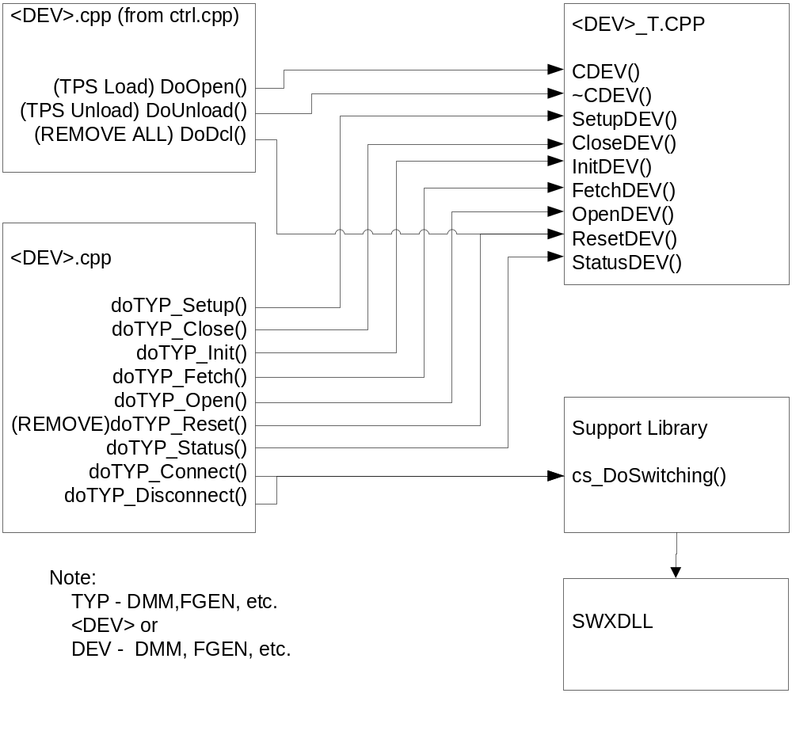
Figure 4.0 WCEM Function Relationships

System Components
The WCEM driver will consist of:

- A Microsoft Visual C++ project to build the WCEM
  - WCEM Wizard generated interface files
    - Wrapper.cpp
    - error.cpp
    - key.h
  - Configuration Information
  - 1553SerialBus.rc
  - resource.h
  - Updated Template File
    - 1553SerialBus.cpp
  - The programmer generated driver file 1553SerialBus_T.cpp

- A PAWS Developer’s Studio project file for the benchmark 1553SerialBus.PAW
  - An ATLAS program or programs to test the driver (Benchmark)
  - A Device Database static Description

Interface design

Function | Purpose
C1553SerialBus(bool sim, int dbglvl, int addr) | This function is used to initialize the instrument, obtain a handle from VISA or other controller software, and establish if the device is in simulation mode and / or debug.
~C1553SerialBus(void) | This function shuts down the instrument and releases the device handle.
Setup1553SerialBus(int fnc) | This function is the entry point for the setup action. The argument is the FNC number from the DeviceDB Static Description.
Status1553SerialBus(void) | This function queries the instrument for status and reports any errors to the RTS via the error handling mechanisms
Fetch1553SerialBus(int fnc) | This function is responsible for retrieving measured values from the instrument and returns them to the RTS via the fetch API in WCEM or other support libraries
Initiate1553SerialBus(int fnc) | This function controls the ATLAS INITIATE actions and is responsible for enabling or triggering a signal
Reset1553SerialBus(int fnc) | This function is responsible for resetting the instrument. The argument 0 will be reserved for a RESETALL action and shall reset the instrument regardless of the current state of the device. Arguments > 0 may use a state variable to determine if the device is currently reset.
Close1553SerialBus(int fnc) | This function is responsible for the ATLAS CLOSE verb and shall close any internal relays within the instrument and will enable the output or input to the device.
Open1553SerialBus(int fnc) | This function is responsible for the ATLAS OPEN verb and will disable the output or input of the instrument.

Detailed Design

Classification
This module is unclassified.

ATLAS Modifier Definition
The following table specifies the Nouns / Measured Characteristics / Modifiers used to control the Model:

Modifier | Dim | Value Range | Default | XML | Misc
ESTABLISH
BUS PROTOCOL |  |  |  |  | <Protocol Name>
SPEC, , STANDARD PRIMARY BUS
MIL-1553B | BUS |  | (type) STANDARD

Modifier | Dim | Value Range | Default | XML | Misc
BUS-PARAMETER <bus-parameter>
RESPONSE-TIME | Sec | 18 usec, 22 usec, 50 usec, 130usec | 0 usec
MESSAGE-GAP | Sec | 0 usec to 65500 usec by 100 usec
PROTOCOL PARAMETER <protocol parameter>
Not Legal
DEFINE EXCHANGE
EXCHANGE |  |  |  |  | <protocol name>
BUS MODE
CONT-RT | N/a
RT-CON | N/a
RT-RT | N/a
CON-MODE | N/a
ALL-LISTENER | N/a
TALKER | <data store> |  | TEST-EQUIP
LISTENER | <data store> |  | UUT
COMMAND | <data store>
DATA | <data store>
STATUS | <data store>
Modifier | Dim | Value Range | Default | XML | Misc
DO EXCHANGE
EXCHANGE |  |  |  |  | <protocol name>
TEST-EQUIP-ROLE
MASTER | N/a
MONITOR | N/a
SLAVE | N/a
TEST-EQUIP-MONITOR
COMMAND | <data store>
STATUS | <data store>
DATA | <data store>
PROCEED | Sec | 0 to MAX-TIME | 0 seconds
WAIT | Sec | 0 to MAX-TIME | 0 seconds
MAX-TIME | Sec
DELAY | Sec

Port Names
The Port Names in the table below provide the naming convention utilized in the Switch Data Base and Model for interface control and management along with the connection field mnemonics to be used by ATLAS programs.

CNX Field | Port Name | Instrument
TRUE | DDC1553b-hi | I/O Diff HI
COMPL | DDC1553b-lo | I/O Diff Lo

Processing
There are no special processing requirements other than normal ATLAS interpretation of the keywords.

Notes

Atlas Examples

Serial Bus Signal

MIL-1553B Signal

Example of programming the ILC/DDC-1553 PCMCIA as Bus Monitor:

000001 BEGIN, ATLAS PROGRAM 'bustst' $
10 ESTABLISH, GLOBAL, BUS PROTOCOL 'mil1553',
SPEC 'MIL-1553B',
STANDARD PRIMARY BUS,
CNX TRUE pin1 COMPL pin2 $
20 DEFINE, 'test', GLOBAL, EXCHANGE, PROTOCOL 'mil1553',
BUS-MODE TALKER-LISTENER,
TALKER 'UUT'(1),
LISTENER TEST-EQUIP $
30 DECLARE, GLOBAL, VARIABLE,TMP',
'I' IS INTEGER;
'cmd-1',
'stat' IS STRING(16) OF BIT;
'list' IS ARRAY (1 THRU 32) OF STRING (16) OF BIT $

E001000 OUTPUT, C'Begin a 1553 transaction for the monitor' $
10 INPUT, INTO 'TMP' $

20 DO, EXCHANGE,
TEST-EQUIP-ROLE 'MONITOR',
EXCHANGE 'test',
TEST-EQUIP-MONITOR COMMAND 'cmd-1',
DATA 'list' (1 THRU 32),
STATUS 'stat',
PROCEED,
MAX-TIME 2 SEC $
90 FINISH $

Requirements traceability
This WCEM driver provides the requirements stated in Paragraph 3.4.4 of the PERFORMANCE SPECIFICATION FOR THE THIRD ECHELON TEST SET (TETS) MARCORSYSCOM-PD-02-001 12/1/2003 and General Notes for ATLAS Implementation Doc # 7992052 Rev.01 Aug 10 2005.

Appendix A –CICL IEEE 1641 TSF Definitions

TSF .XSD Signal Description
- 1553SERIALBUS_1_VOLTAGE
- 1553SERIALBUS_1_CURRENT
- 1553SERIALBUS_1_RESISTANCE

Reference TETS_1553SERIALBUS_TSF.XSD

TSF .XML Signal IEEE 1641 TSF Library
- 1553SERIALBUS_1_VOLTAGE
- 1553SERIALBUS_1_CURRENT
- 1553SERIALBUS_1_RESISTANCE

Reference TETS_1553SERIALBUS_TSFLib.xml

Appendix B – Mathematical Equations
AC Signal

1. Voltage to Voltage-PK
Voltage-PK value = voltage_value * RMS_PK

2. Voltage-PK to Voltage
Voltage value = voltage-pk_value / RMS_PK

3. Voltage to Voltage-PP
Voltage-PP value = voltage_value * RMS_PP

4. Voltage-PP to Voltage
Voltage value = voltage-pp_value / RMS_PP

5. Voltage to Watt
Watt value = (voltage_value)² / impedance value

6. Watt to Voltage
Voltage value = sqrt(watt value) * impedance value

7. Voltage to dBm
For a 50 ohm test equipment impedance
dBm value = 20 log (voltage_value / DBM_50_OHM)

For a 600 ohm test equipment impedance
dBm value = 20 log(voltage_value / DBM_600_OHM)

8. dBm to Voltage
For a 50 ohm test equipment impedance
Voltage value = 10^{dBm_value / 20} * DBM_50_OHM
For a 600 ohm test equipment impedance
Voltage value = 10^{dBm_value / 20} * DBM_600_OHM

9. Watt to dBm
dBm value = 10 log (watt_value / .001)

10. dBm to Watt
Watt value = 10^{dBm_value / 10} * .001

Square Wave Signal - This is for a 50% Duty Cycle only and can only be done for this Duty Cycle. Any other Duty Cycle not allowed.

1. Voltage to Voltage-PP
Voltage-PP value = voltage_value * 2

2. Voltage-PP to Voltage
Voltage value = voltage-pp_value / 2

3. Voltage to Voltage-PK
Voltage-Pk value = voltage_value

4. Voltage-PK to Voltage
Voltage value = voltage-pk_value

Triangular Wave Signal - This is for symmetrical Triangular wave signal. Any other symmetry for this wave is not allowed.

1. Voltage to Voltage-PK
Voltage-PK value = voltage_value * RMS_TRI_PK

2. Voltage-PK to Voltage
Voltage value = voltage-pk_value / RMS_TRI_PK

3. Voltage to Voltage-PP
Voltage-PP value = voltage_value * RMS_TRI_PP

4. Voltage-PP to Voltage
Voltage value = voltage-pp_value / RMS_TRI_PP

Constants used for Mathematical Equations

RMS_PK = sqrt(2) = 1.414213562373 rounded to 12 decimal place.

RMS_PP = RMS_PK * 2

RMS_TRI_PK = sqrt(3) = 1.73205080808 rounded to 11 decimal place

RMS_TRI_PP = RMS_TRI_PK * 2

DBM_50_OHM = .22360679775 rounded to 11 decimal place
1mw = E²/50 equals sqrt(.05)

DBM_600_OHM = .7745966692414 rounded to 13 decimal place
1mw = E²/600 equals sqrt(.6)

